User Guide for Task 2 (MTR Route Finder)
Step 1:
Import or open “MTR” file to code editor, such as Visual Studio Code or PyCharm.
Step 2:
Click “UI.py” file and run it.
Step 3:
A window will pop up. Select a Starting station and Destination (Either use the drop-down menu or type in the text box). Then click “Search Route”.
Step 4:
The corresponding information will show up below. (Selected starting point and destination, The station passthrough in-between the journey, Total travelling time).

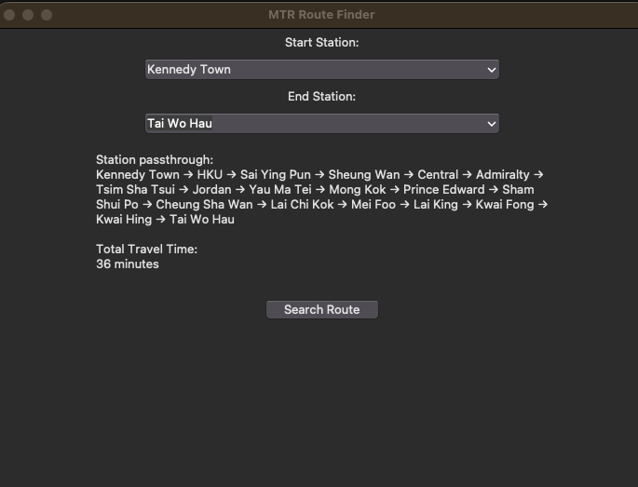
Head and End would be the starting point and destination. Middles are the station passthrough.
Select a starting station and destination by using drop-down menu or text box.
Total travelling time for the whole journey.

